**Fawry SQL Test**

These are sample tables that you will need for answering all questions except the final question. Please build your queries to fit these sample and any other sample from the whole data.

**Monthly_Sales_Table** **Merchant_Info_Table**

**Q1)** Get the last Month_Amount value for each Merchant.

Show Merchant_ID, Month_Code and Month_Amount. **Expected Output**

select Merchant_ID,Month_Code,Month_Amount from (

select

row_number() over(partition by Merchant_ID order by Month_Code DESC) as rnk,Merchant_ID,Month_Code,Month_Amount

from Monthly_Sales_Table)AA

WHERE AA.rnk=1;

**Q2)** Get the last 3 months avg (201705,201704,201703) for each merchant while displaying all months’ values. For FAWRYRTL Channel only.

Show Merchant_ID, Month_Code, Month_Amount and Last_3_Month_AVG. **Expected Output**

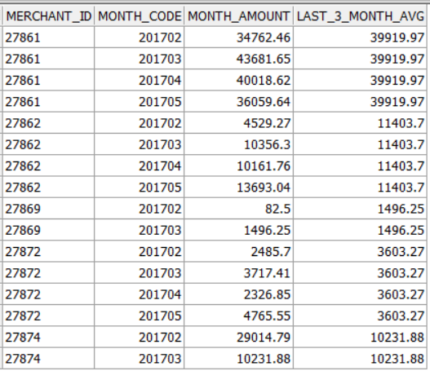

**AS Expected Ouptut:**

SELECT AA.Merchant_ID,AA.Month_Code,AA.Month_Amount,Last_3_Month_AVG

FROM Monthly_Sales_Table AA

LEFT JOIN (

SELECT Merchant_ID, ROUND(AVG(Month_Amount),2) AS Last_3_Month_AVG

FROM Monthly_Sales_Table

WHERE Month_Code IN (201705, 201704, 201703)

GROUP BY Merchant_ID)BB ON AA.Merchant_ID=BB.Merchant_ID;

**AS mention in question:**

SELECT AA.Merchant_ID,AA.Month_Code,AA.Month_Amount,Last_3_Month_AVG

FROM Monthly_Sales_Table AA

LEFT JOIN (

SELECT Merchant_ID, ROUND(AVG(Month_Amount),2) AS Last_3_Month_AVG

FROM Monthly_Sales_Table

WHERE Month_Code IN (201705, 201704, 201703)

GROUP BY Merchant_ID)BB ON AA.Merchant_ID=BB.Merchant_ID

WHERE AA.Merchant_ID IN (SELECT Merchant_ID FROM Merchant_Info_Table WHERE Channel='FAWRYRTL');

**Q3)** Get the Total Sales of 201704 for each merchant while displaying all months’ values and merchants that don’t have sales in this month 201704 substitute by 0.

Show Merchant_ID, Month_Code, Month_Amount and April_Total_Sales. **Expected Output**

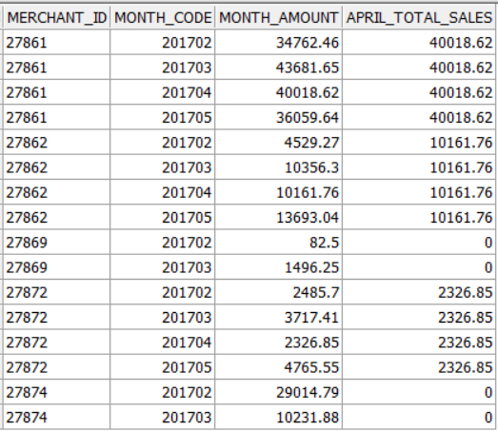

SELECT AA.Merchant_ID,AA.Month_Code,AA.Month_Amount,

COALESCE(BB.Last_3_Month_AVG,0) as Last_3_Month_AVG

FROM Monthly_Sales_Table AA

LEFT JOIN (

SELECT Merchant_ID, ROUND(AVG(Month_Amount),2) AS Last_3_Month_AVG

FROM Monthly_Sales_Table

WHERE Month_Code = 201704

GROUP BY Merchant_ID)BB ON AA.Merchant_ID=BB.Merchant_ID;

**Q4)** Get the last 3 values of column Month_Amount of each merchant with 15 working days at least

Show Merchant_ID, Month_Code and Month_Amount. **Expected Output**

select Merchant_ID,Month_Code,Month_Amount,Working_Days from (

select

row_number() over(partition by Merchant_ID order by Month_Code desc ) as rnk,Merchant_ID,Month_Code,Month_Amount,Working_Days

from Monthly_Sales_Table

where Working_Days>=15

)AA

WHERE AA.rnk<=3;

**Merchant_Action_Table**

**Q5)** Merchant is in red zone When his balance is below red balance. Else he is in green zone.

Get merchant zone start date and end date across the whole month.

Show Merchant_ID, Zone, Start_date and End_Date. **Expected Output**

**The expected ouput contains data not in the sample provide of table so I apply query as following trying to get the zone start and end date by using Lag function to get the zones and lead o the end date**

SELECT

FF.Merchant_ID,

FF.START_DATE,

FF.END_DATE AS END_DATE,

FF.ZONE

FROM

( SELECT

BB.Merchant_ID,

BB.ACTION_DATE AS START_DATE,

LEAD(BB.ACTION_DATE) OVER (ORDER BY BB.ACTION_DATE) AS END_DATE,

ZONE

FROM

( SELECT

AA.Merchant_ID,

AA.ACTION_DATE,

AA.ZONE,

LAG(AA.ZONE) OVER (ORDER BY AA.ACTION_DATE) AS PREV_ZONE

FROM

(SELECT

Merchant_ID,

ACTION_DATE,

BALANCE_AFTER,

RED_BALANCE,

CASE

WHEN BALANCE_AFTER < RED_BALANCE THEN 'RED'

ELSE 'GREEN'

END AS ZONE

FROM

Merchant_Action_Table ) AA)BB

WHERE

ZONE != PREV_ZONE OR PREV_ZONE IS NULL)FF

ORDER BY

FF.START_DATE;